Sprint 1 Plan

dndsip.ga by dndsip: V 1.0.0

Complete on October 21st, 2018. V.1.0 - Last revised October 8th 2018.

**Goal:** Our goal for this sprint is to familiarize ourselves with the tools we will be using and to create a drop down dice roller.

|  |  |
| --- | --- |
| Sprint 1 |  |
| *User Stories, priority ordered* | *Story Points* |
| **Sprint 1** | 48 (total) |
| As a developer, I would like all of our team members to learn how to interact with the pages on our web server so that our developers can edit the website. | 2 |
| As a developer, I would like all of our team members to have a basic understanding of digitalocean.com in so that they can monitor and make any changes necessary to our site. | 2 |
| As a developer, I would like all of our team members to have a basic understanding of CSS and HTML so that they can work on the website. | 8 |
| As a developer, I would like all of our team members to have a basic understanding of the JavaScript language so that they can work on the website. | 8 |
| As a developer, I would like all of our team members to have a basic understanding of the JQuery language so that they can work on the website. | 5 |
| As a developer, I would like all of our team members to have a basic understanding of PHP so that they can work on the website. | 5 |
| As a developer, I would like all of our team members to learn how to interact with the database on our web server so that our users can store data on the site. | 5 |
| As a user, I would like to have access to a drop down menu dice roller that I can access from my character sheet or from the DM tools screen. | 13 |

**Task Listing:**

1. As a developer, I would like all of our team members to learn how to interact with the pages on our web server so that our developers can edit the website.
   1. Create an account on the web server and SSH into it
   2. Edit the index.html file with their name so that it shows up on the website
2. As a developer, I would like all of our team members to have a basic understanding of digitalocean.com in so that they can monitor and make any changes necessary to our site.
   1. Login to our digitalocean account and look at the basic information.
   2. Visit [this link](https://cloud.digitalocean.com/networking/domains/dndsip.ga?i=330b0d) and understand what DNS and domain names are. Note that TTL is just how long a page is cached in a user’s browser.
3. As a developer, I would like all of our team members to have a basic understanding of CSS and HTML so that they can work on the website.
   1. Visit [this link](https://www.khanacademy.org/computing/computer-programming/html-css) to learn about CSS and HTML. Go through as much of the course as you think you need, but understand that this is one of the best resources available.
   2. You can always visit [W3 schools](https://www.w3schools.com/html/default.asp) to learn more or have a handy reference.
4. As a developer, I would like all of our team members to have a basic understanding of the JavaScript language so that they can work on the website.
   1. Use whatever resources you would like in order to learn about JavaScript. KhanAcademy, W3 Schools, any YouTube videos are always a good source.
   2. **Keep in mind:** You do not need to start with the basics of programming. Once you know one programming language, it just becomes a matter of understanding syntax (e.g. how to code a for loop in JavaScript versus in Python) and what makes that language special (e.g. JavaScript is asynchronous and not strongly typed).
5. As a developer, I would like all of our team members to have a basic understanding of the JQuery language so that they can work on the website.
   1. Visit [this link](https://www.w3schools.com/jquery/default.asp) and read what is under the “JQuery Tutorial” section on the left side of the page.
   2. At the same link, read what is under the “JQuery HTML” section on the left side of the page.
   3. If you need anymore than this, just go back to W3 Schools. They are a great reference tool for JQuery.
6. As a developer, I would like all of our team members to have a basic understanding of PHP so that they can work on the website.
   1. Learn what PHP is.
   2. Find resources online for learning basic PHP. It’s up to you how you do this.
7. As a developer, I would like all of our team members to learn how to interact with the database on our web server so that our users can store data on the site.
   1. Find resources online for learning how to do this.
   2. Then, create an HTML page with a textbox. When you hit submit on the text box, it saves that data to the server. Then, you hit a retrieve button which displays that data on the page.
8. As a user, I would like to have access to a drop down menu dice roller that I can access from my character sheet or from the DM tools screen.
   1. Create HTML/CSS for a global bar at the top of every page.
   2. Create HTML/CSS for a drop down div.
   3. Create HTML/CSS and JavaScript/JQuery for a dice roller in this div.

**Team Roles:**

Michael Hypnarowski: Product Owner

Allan Wong: Developer

Connor (Robert Sanders): Developer

Jensen Li: Developer

Viren Singh: Scrum Master (, Developer)

**Initial Task Assignment:**

Michael: Understand digital ocean, login and monitor network.

Allan: Gain an understanding of PHP, look up an online tutorial.

Connor: Gain an understanding of CSS/HTML, visit Khan Academy lectures.

Jensen: Interact with web server, ssh and make an account.

Viren: Gain understanding of JavaScript, take a refresher course.

**Initial Burnup Chart:**

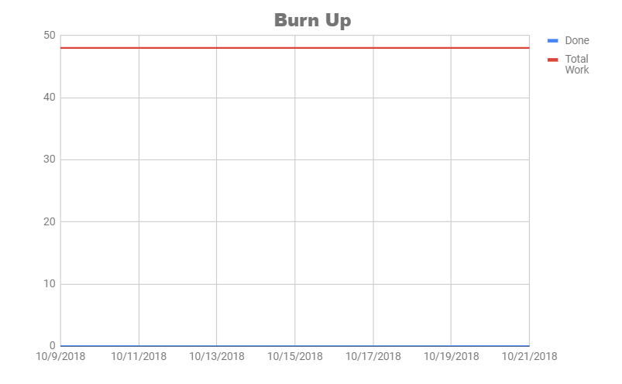

**Initial Scrum Board:**

**Scrum Times:**

|  |  |  |
| --- | --- | --- |
| **Day** | **Time** | **Location** |
| Tuesday | 6:00pm | Jack Baskin 302/316/340ab |
| Thursday (TA meeting) | 6:00pm | Jack Baskin 302/316/340ab |
| Saturday | 6:00pm | Jack Baskin 302/316/340ab |